**Lab-Task-1:**

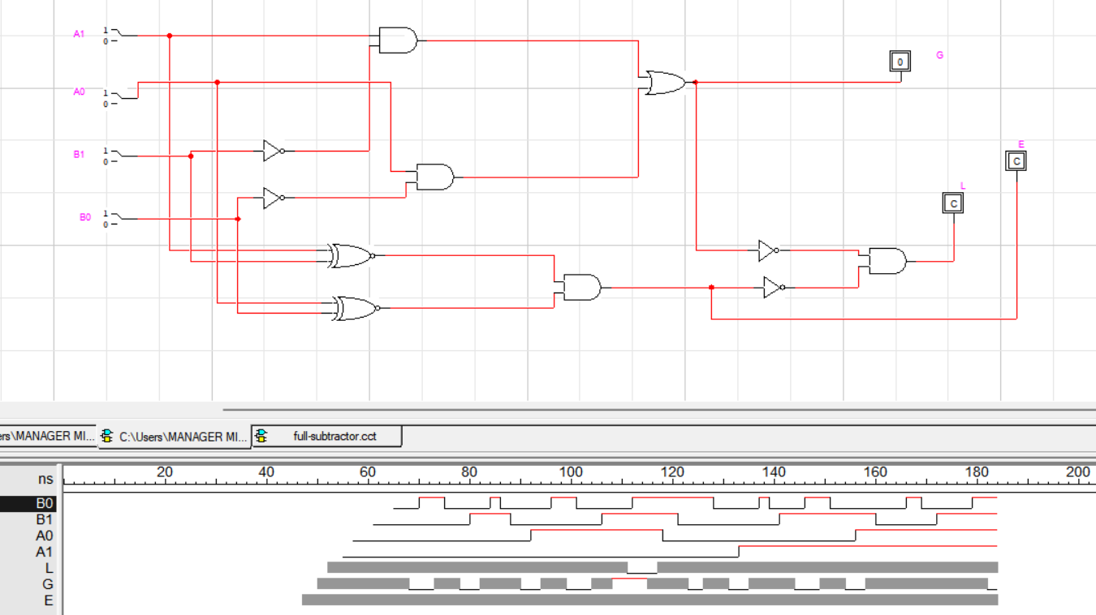

**Comparator**

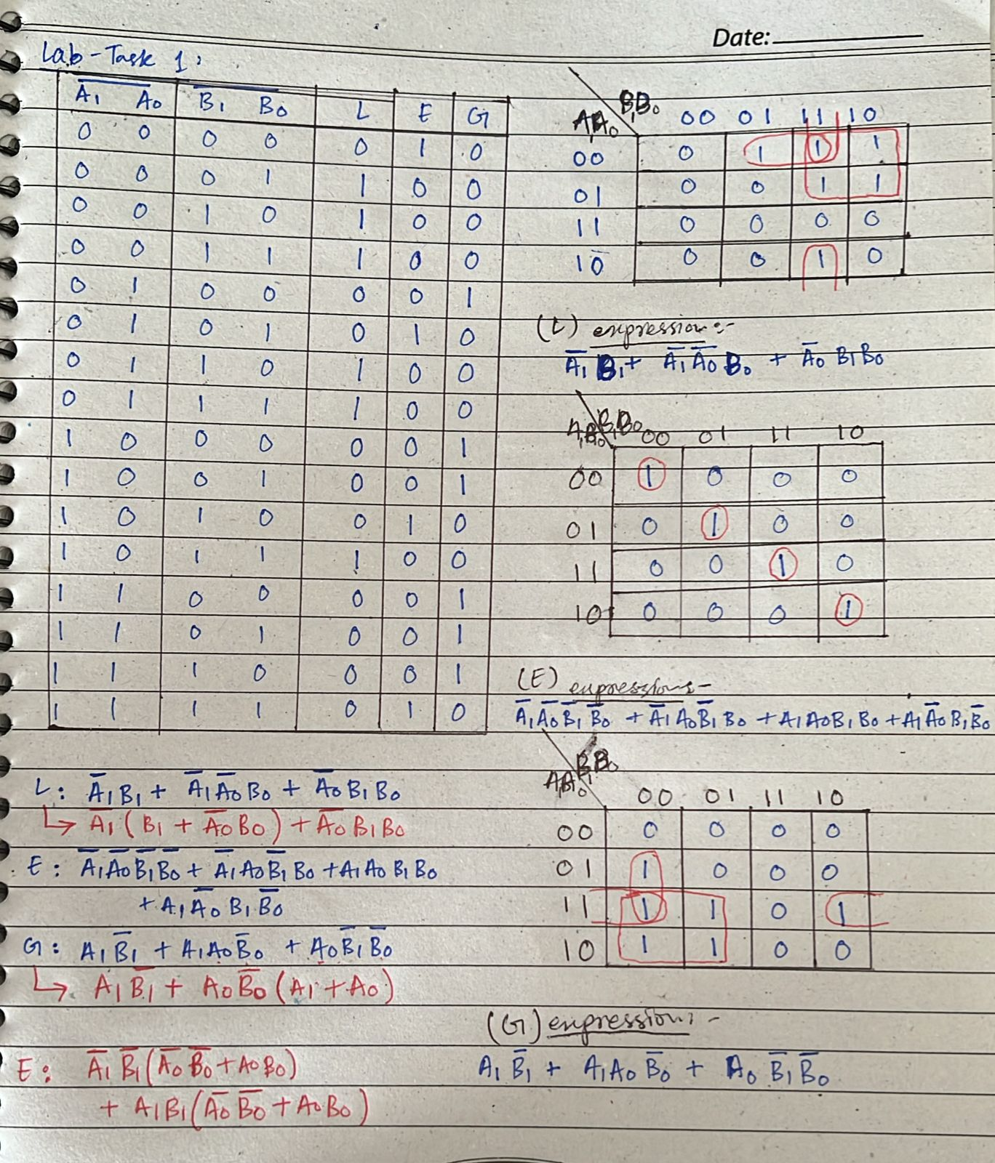**G = Greater (A0 A1 > B0 B1)**

**L = Lesser (A0 A1 < B0 B1)**

**E = Equal (A0 A1 = B0 B1)**

**Lab-Task-2:**

**MAIN:**

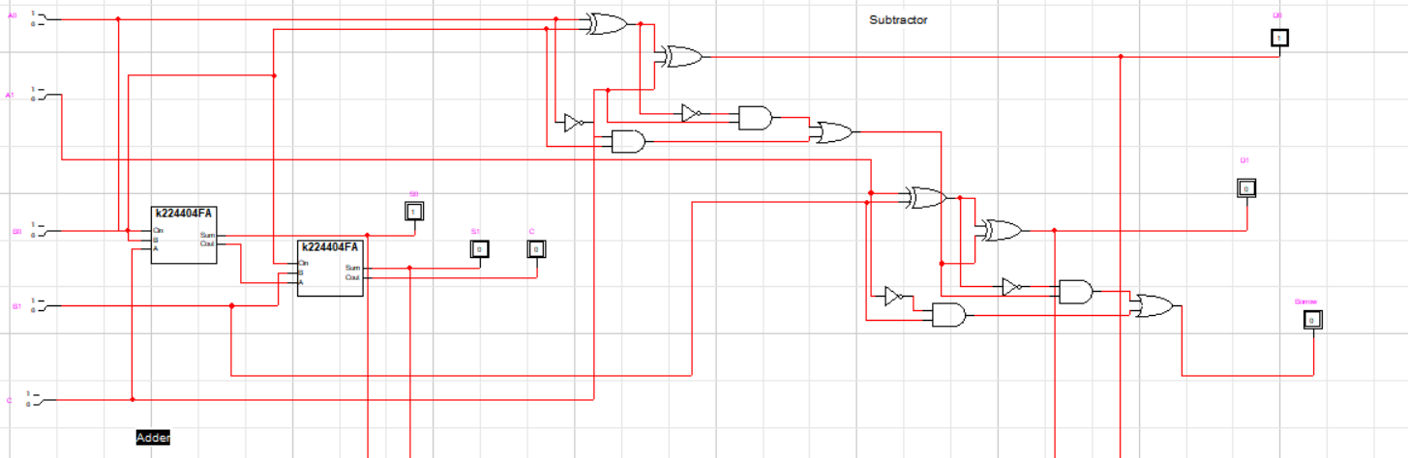

**| | | |**

**| | | |-----------------------------------|**

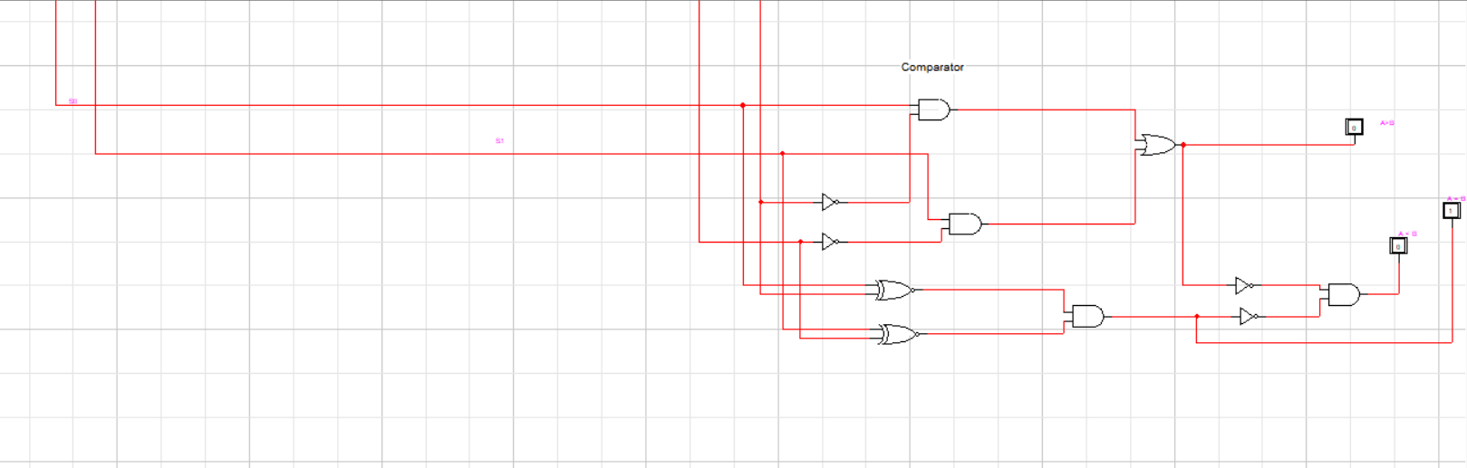

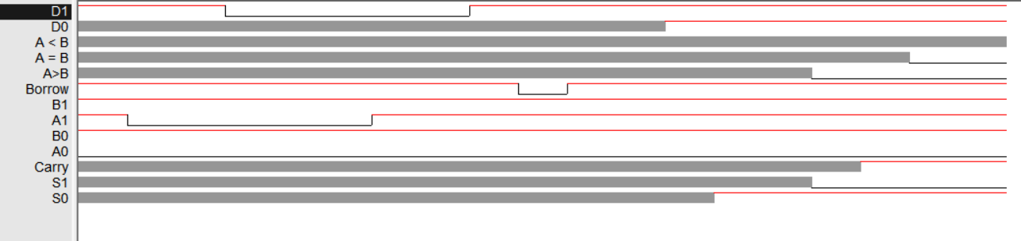

**1 →A1 0 →A0 S1 and S0 = Sum**

**→ Inputs**

**0 →B1 1 →B0 D1 and D0 = difference**

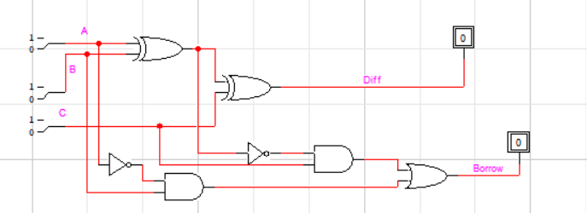 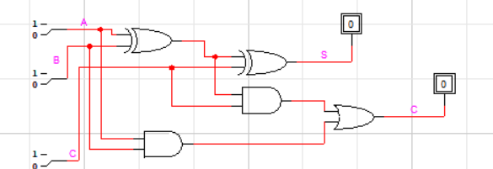

**Subtractor Adder**

**Lab-Task-3:**

